User Guide for ECA cards

- ECA Card- (E for Elements, C for Creativity, A for Association)

There is a box of cards, containing 16 pieces of different elements:
“Colour”, “Line”, “Form”, “Texture”, “Shape”, “Space”, “Object”, “IDEA”

1. Students sit as a circle.
Make sure each student get the draft of another student.

3. Face down all ECA cards and mix them.

4. Each student pick one ECA card from the pile.

5. They have to follow the instruction on the ECA card, associate or modify the draft on the given paper with that ECA element.
* The association or modification should be made on a tracing paper.

6. Duration for each round is 4-5 mins.
Then the papers with be passed to another student in clockwise direction.

7. Then the cards are mixed and students have to draw a card again.

**Numbers of rounds depend on duration of activity time.
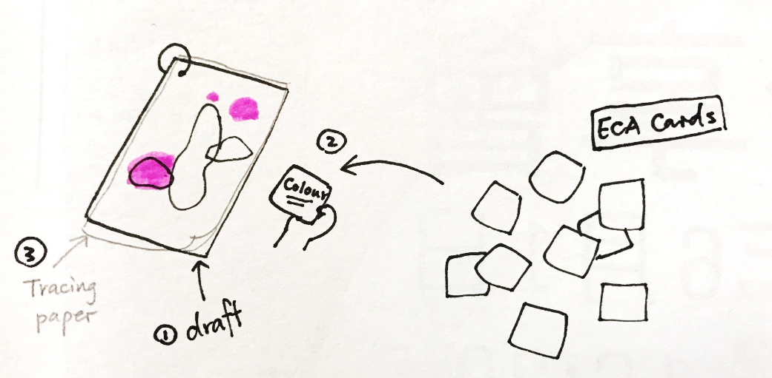
Students will get their drafts back, together with comments and drafts of other students.
Students choose the most creative idea from other students and talk about the reason of their choices.

The main purpose of the activity is to encourage feedbacks among students and develop confidence to express student’s creativity.

